**Title: DNA sequences from two non-avian dinosaurs**

**Authors:** Hyunmin Kim1*†, Arushi Khanna1†, Henry Wittler1, Rômulo Carleial2, Wenxia Zheng3, Elena R. Schroeter3, Mary H. Schweitzer3,4*, Berkley E. Gryder1*

**Affiliations:**

1Department of Genetics and Genome Sciences, Case Western Reserve University, Cleveland, Ohio, USA

2Royal Botanic Gardens, Kew, Richmond, England, UK

3Department of Biological Sciences, North Carolina State University, Raleigh, NC, USA

4North Carolina Museum of Natural Sciences, Museum of the Rockies, and Dept of Geology, Lund University

†These authors contributed equally to this work

*Correspondence: hyunmin.kim2@case.edu, mhschwei@ncsu.edu, berkley.gryder@case.edu

**Abstract:** Studies of ancient DNA have revolutionized our understanding of extinct organisms, but thus far the maximum estimated age of sequenced DNA is two million years. However, evidence for endogenous biomolecules, including proteins, lipids, and pigments have been found in much older fossils, dating to up to 195 million years. Amino acid sequence data consistent with ancient, endogenous biomolecules have been derived from specimens of the theropod *Tyrannosaurus rex* (MOR 1125)andthe hadrosaur *Brachylophosaurus canadensis* (MOR 2598). Histochemical and immunological studies also identified a molecule consistent with DNA in these two ancient specimens, localized to a single point within preserved osteocytes. Here we report the sequencing and analysis of DNA extracted from osteocytes and blood vessels of *T. rex* and *B. canadensis*, liberated after demineralization of dense cortical bone. Usable sequence reads were obtained at a low recovery rate. After the removal of high-quality reads that mapped to the human genome, the remaining reads were highly fragmented, with similarities to multiple animal species including reptilian and avian genomes. Our findings support the hypothesis that DNA and histone signal from imaging, mass spectrometry, and DNA sequencing of dinosaur osteocytes are endogenously preserved biomolecules.

**One-Sentence Summary:** We present preliminary genomic evidence for the presence of endogenous ancient DNA from cells and blood vessels found in the bony remains of two Cretaceous dinosaurs.

**Main Text:**

The study of ancient DNA (aDNA) has opened up a previously inaccessible windows into the past. Work in recent decades has elucidated the phylogenetic relationships among ancient species and their living relatives (1, 2,3), the process of domestication of both crops (4) and animals (5), and even characterized whole ancient ecosystems (6). Despite these recent advancements, studies have been constrained by the inherent challenges of working with aDNA, which is usually highly fragmented, chemically damaged, and contaminated with environmental or human DNA (7). The preservation of aDNA from fossils dating multiple millions of years has therefore been considered unlikely (8,9). However, fossil age is a poor predictor of aDNA preservation, and favourable conditions during fossil formation may substantially reduce aDNA fragmentation (10). Accordingly, the record for the oldest preserved aDNA has been increasingly extended over the past years (11) inviting the exciting possibility that aDNA from much older samples may have survived the test of time.

During the past two decades, a series of studies have provided multiple lines of evidence for the preservation of endogenous biomolecules and soft-tissue structures inside ancient fossil bones from dinosaurs (12, 13, 14, 15, 16,17). Numerous groups have independently accumulated evidence of proteins, and mass-spectrometry of these proteins supports an endogenous origin (18, 19, 20, 21,22), rather than modern contamination. Osteocyte-like cells within these fossils were positive for DNA via antibody staining and DNA intercalating dyes (PI and DAPI), the signal from which was consistently confined within a small central structure resembling the nucleus (23).

Histone proteins are eukaryote specific and stabilize double-stranded DNA when it wraps around the histone octamer. Because histones are highly conserved among vertebrates, we considered that their presence in cells extracted from the dense cortical bone of these specimens could serve as additional evidence that the DNA detected was endogenous and could not be attributed to bacteria (24). We repeated previous experiments on new isolates of osteocytes, using antibodies against the DNA backbone and histone proteins, as well as the DNA intercalating stains DAPI and PI (Figure 1B) to identify these components interior to the osteocytes, consistent with the localization of DNA in these cells. Then, for the first time, we demonstrated the co-localization of DNA and histones in these dinosaur cells through dual labeling (Extended Data Figure 1). New bioinformatic analyses of proteomic data previously recovered from these two dinosaurs by mass spectrometry (18,19) (Figure 1C) also identified histone peptides that were not present in the negative controls. Interestingly, the only histone peptides identified from dinosaur bones were interior to the core of the nucleosome “bead” around which DNA wraps (Figure 1D), and not from the long and disordered “tails” that serve as a substrate for epigenetic memory in vertebrates. DNA preservation may be dependent on the histone core particle, and vice versa. While bacteria25 and archaea26 lack a nucleus, they compact DNA using histone-like particles with amino acid sequences highly divergent from all known vertebrates, while the structure27 and amino acid sequences among vertebrate histones are largely invariant28.

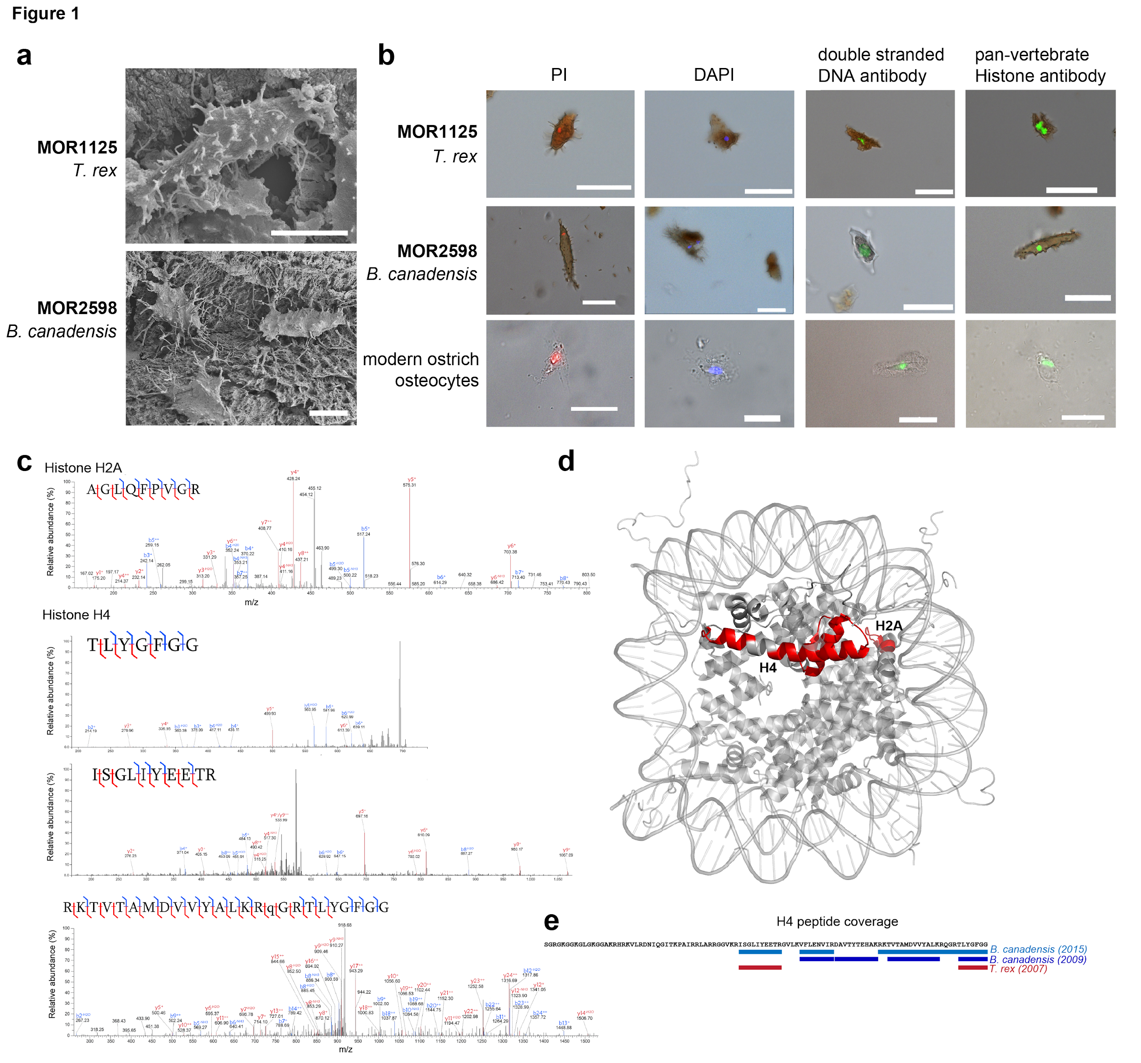

**Fig. 1. DNA and histones detected in dinosaur osteocytes.** **A**. Scanning Electron Microscopy highlighting the presence of osteocytes in *Tyrannosaurus rex* (top), and *Brachylophosaurus canadensis* (bottom). **B.** Fluorescence microscopy of osteocytes isolated from *T. rex* (upper panels), *B. canadensis* (middle panels), and a modern *Struthio camelus* (ostrich, bottom). Cells were stained using four different methods (PI = Propidium Iodide; DAPI = 4′,6-diamidino-2-phenylindole; Anti-histone; Anti-DNA), and suggested the presence of endogenous DNA. **C**. Annotated spectra of histone H2A and H4 peptides identified in fossil tissues using mass spectrometry. Top panel: representative histone H2A peptide from *B. canadensis.* Second and third panels: representative histone H4 peptides from *T. rex.* Bottom panel: representative histone H4 peptide form *B. canadensis.*  **D**. Structure of a nucleosome core particle, with fragments detected by mass-spectrometry of histone H2A and histone H4 highlighted in red. **E**. Map of histone H4 sequence coverage detected from fossil tissues. Top (blue, 2015 report, and purple, reported in 2009) and bottom (red, reported in 2007) bars represent histone peptides identified and annotated in this paper (see Supplementary Information) from previously published *B. canadensis* blood vessel (19) and *T. rex* (18) mass-spectrometry data, respectively. Middle bars (purple) are peptides previously reported from *B. canadensis* whole bone extracts(23).

Based upon these and previous data, we reasoned that the possible presence of DNA interior to the cell structure may retain some intact, although highly fragmented, strands of endogenous double-stranded DNA that may be sequenced with newer technology. To test this, we applied a protocol optimized for constructing genomic references from diverse vertebrate species. Bone samples from these two dinosaurs were demineralized and subjected to stringent filtration to collect cells and vessels as previously described (e.g., 29,17,19,30,23). After isolation, cells and vessels were treated with the iron chelator PIH to reduce enzyme inhibition (31,19). DNA was subsequently isolated, crosslink-reversed, and input into the library preparation protocol described within the KAPA HyperPrep Kit (Roche). Fragment size distributions from amplified DNA libraries contained between 40–60% adapter-only fragments (~105 bp average), and insert-containing fragments averaged 360–390 bp per sample, which decreased in abundance with increased size. Libraries were sequenced to maximum depth, consuming all of the product, resulting in 21 million (M) reads for *T. rex* osteocytes, 17M for *T. rex* blood vessels, 700M for *B. canadensis* osteocytes, and 480M for *B. canadensis* blood vessels.

Among these reads, the majority (75–93%) were adapter-only reads, many were low complexity or repetitive (3–11%), <1% were short (less than 15 bp), and the remainder were of mappable quality (2–16%, Figure 2a). These were in stark contrast to modern samples, ancient human DNA, and microbiomes from dinosaur fossils, all of which contained greater than 96% high-quality reads (Figure 2a). Reads sequenced from modern samples are almost all complete (150 bp in length), while read length distributions for *T. rex* and *B. canadensis* were highly fragmented (Figure 2b), a signature of aDNA. Nevertheless, *T. rex* yielded between 473,000–1,000,000 reads per sample (from ~200 ng DNA), and *B. canadensis* yielded between 15.6–74.7 million reads per sample (from 1.0–2.8 µg DNA, Figure 2c). For comparison, we prepared modern DNA from osteocytes isolated from extant ostrich (*Struthio camelus*) bone using lower input DNA amounts (87 ng) and yielded 143 million reads (0.1X coverage, Figure 2c). Reads that mapped to non-human genomes did not include longer read sizes, while reads mapping to the human genome were predominantly complete (150 bp, Extended Data Figure 2). As these samples were multiplexed with human cancer cells during sequencing to increase DNA sequence diversity and avoid sequencing failure, we could not rule out the possibility, *a priori*, of barcode misreading or inaccurate flowcell cluster formation (also known as “index-switching”32).

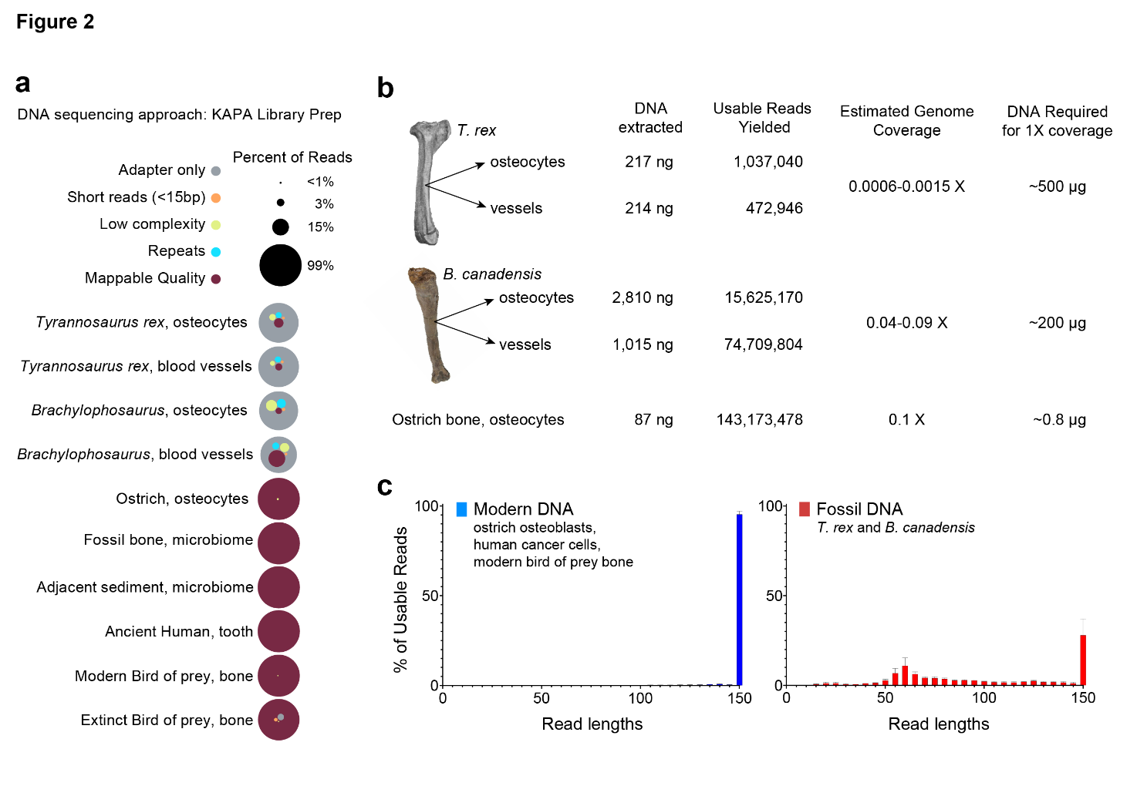

**Fig. 2.** **Fossil DNA sequencing read fragmentation.****A.** Quality distribution of sequencing reads from dinosaur fossils (*Tyrannosaurus rex*, MOR 1125 and *Brachylophosaurus canadensis*,MOR 2598), ostrich bone (this study), microbiome from a dinosaur bone (*Centrosaurus apertus*, BB 180) and its adjacent sediment microbiomes33, a Bronze Age human tooth34, and both modern (*Caracara plancus*, UF 38956) and extinct (*Caracara creightoni*, UF 241647) bird of prey bones [PMID: 31381968](https://pubmed.ncbi.nlm.nih.gov/31381968/). **B.** Read fragment size distribution for modern DNA (left) and DNA extracted from fossil bones (right). **C.** Recovery rates of usable reads from dinosaur fossil bones compared to modern ostrich bone DNA prepared in the same manner. Estimated coverage for dinosaur samples assumes a genome size range similar to modern birds and reptiles (1.3–2.5 Gb).

Next, to evaluate the prevalence of contamination from invading prokaryotes (bacteria, archaea) we applied a metagenomics approach. As a positive control, we included microbial sequencing reads extracted from bones of the ceratopsian dinosaur *Centrosaurus* (33). For negative controls, we included DNA sequenced from modern ostrich osteocytes and a Bronze Age human tooth (34). We used the metagenomic classification tool Centrifuge, which applies the Burrows-Wheeler transform and the Ferragina-Manzini index (35), and simultaneously evaluated reads for eukaryotic, prokaryotic, or viral sequence identity. The *T. rex* and *B. canadensis* data lacked microbial (prokaryotic) sequences but were enriched for eukaryotic reads, especially from vertebrates (Figure 3A). Modern ostrich osteocyte reads were nearly all mapped to avian genomes, and likewise reads from an ancient human tooth were mapped exclusively to primate reference genomes (Figure 3B). *T. rex* and *B. canadensis* sequences were mapped divergently across a range of vertebrates but were enriched for both reptiles and birds (Figure 3B). This was confirmed through single-genome alignment of representative vertebrates (Extended Data Figure 3).

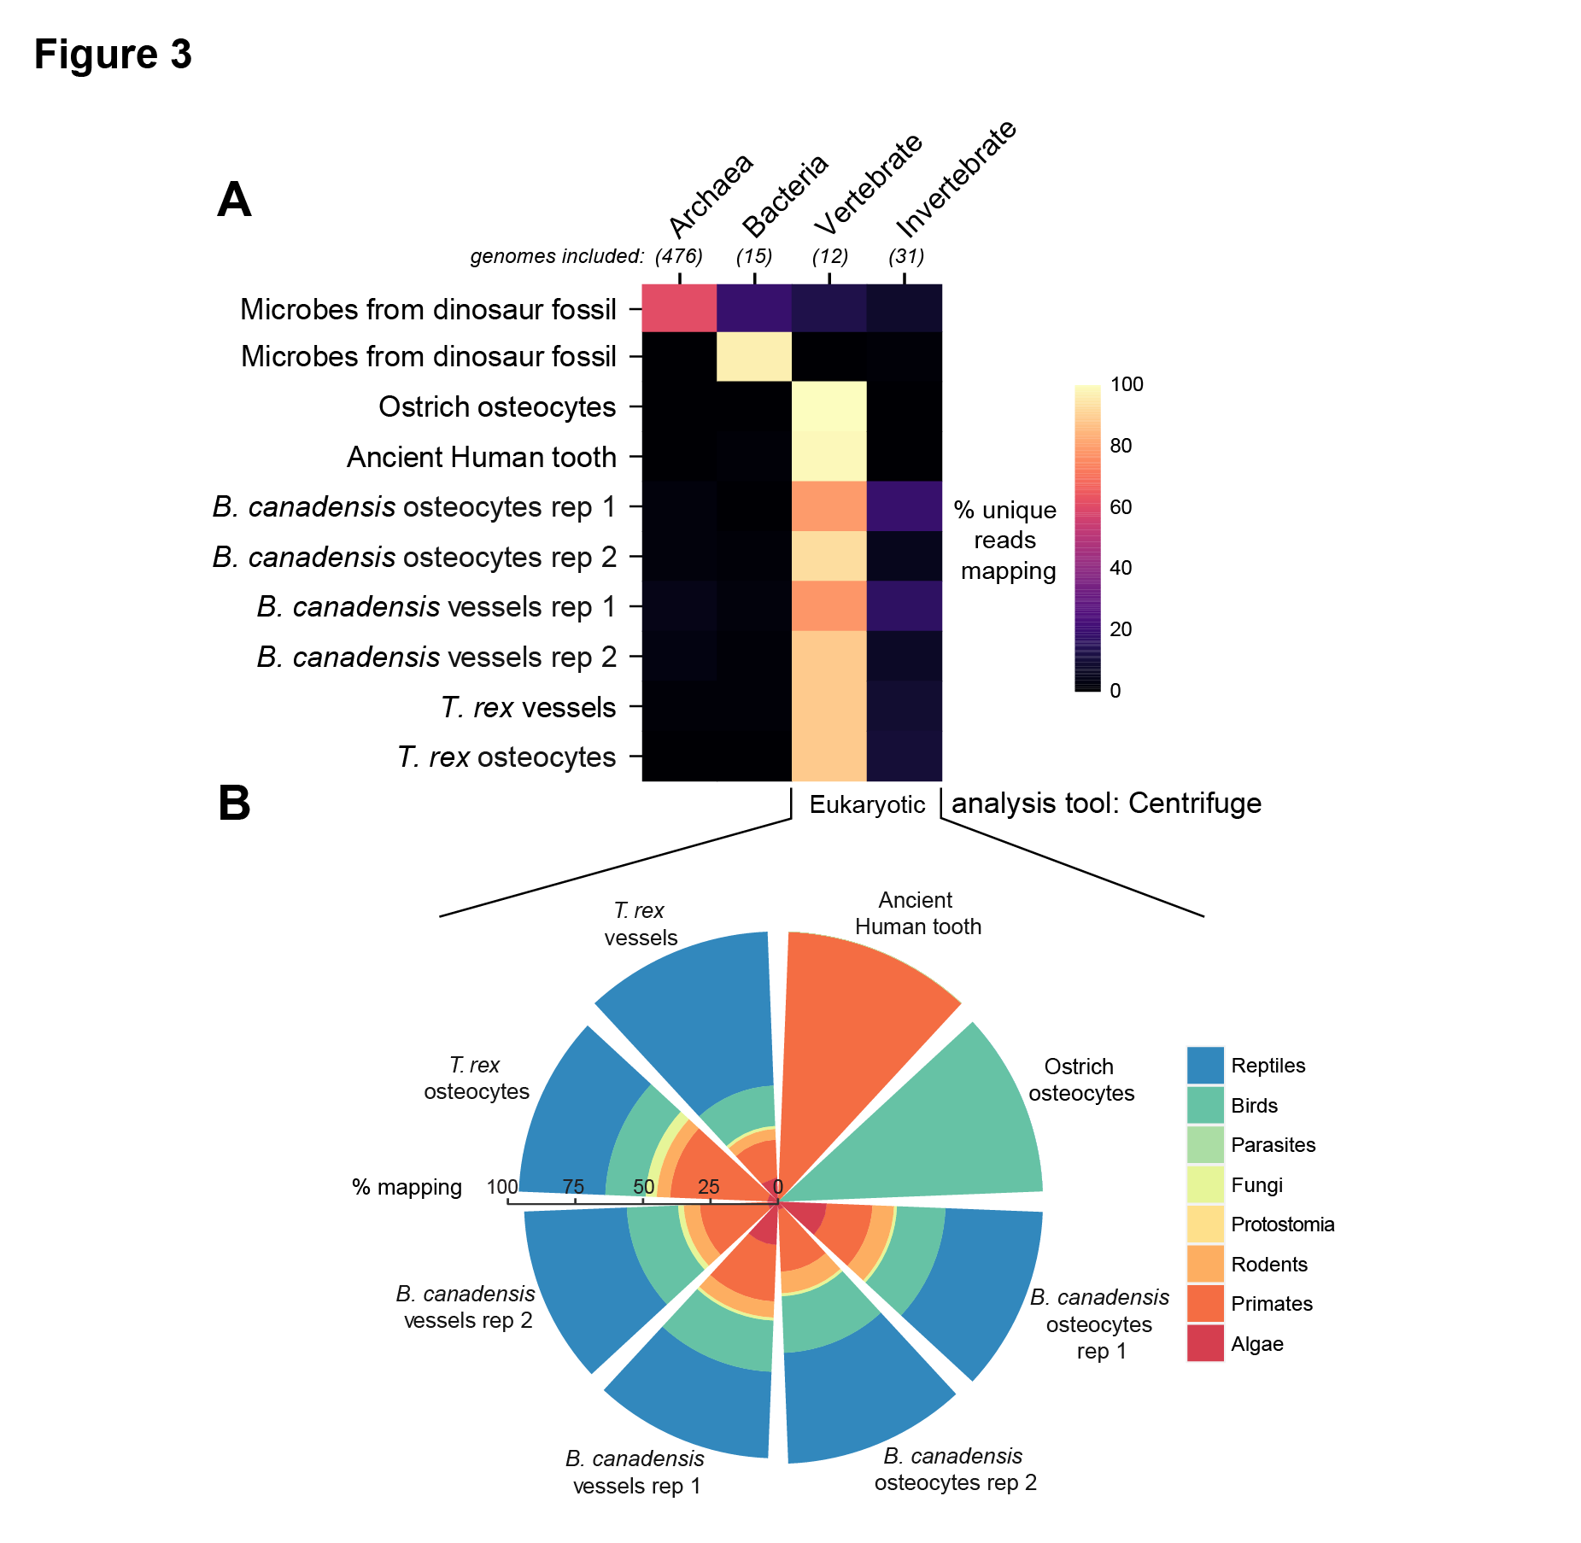

**Fig. 3.** **Alignment of dinosaur reads to diverse reference genome categories.** **A**. Results of Centrifuge metagenomic alignment of reads from *T. rex*, *B. canadensis*, ostrich, human and microbial samples across prokaryotic and eukaryotic genomes. **B.** higher resolution image depicting unique reads mapping to eukaryotic genomes.

We found 7.1 million reads, totaled across all four aDNA fossil samples, mapping to the galGal6 genome (chicken). We evaluated where the reads were aligning (exons, introns, repetitive elements, or intergenic locations). Despite low coverage, the distribution across each element agreed with the expected background genome (Extended Data Figure 4A). Furthermore, at positions of base pair variation from the reference, we evaluated the similarity across all four dinosaur samples and found sequence similarity was high between sequences from osteocytes and vessels taken from the same fossil species (Extended Data Figure 4B).

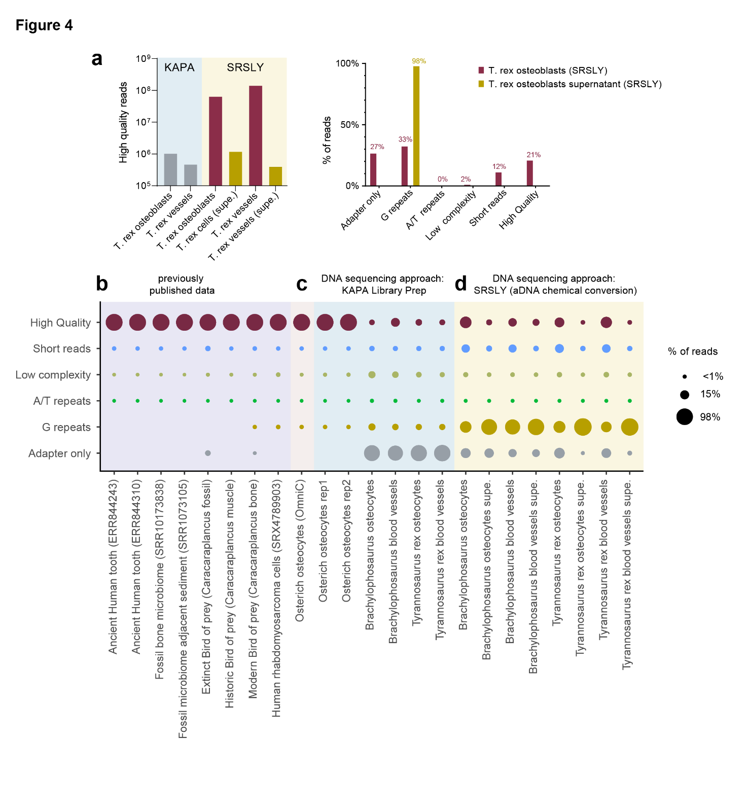**Figure 4.** **Improvements in library conversion chemistry improve DNA yield from ancient osteocytes. A.** Left panel: The number of high-quality reads extracted from cell pellets of T. rex, followed by sequencing with KAPA or SRSLY DNA library preparation methods. Right panel: Percentage of reads by fastqc quality filtering metric for previously published samples. **B-D.** Percentage of read quality for previously published samples (**B.**), samples prepared for initial sequencing investigation with KAPA DNA library preparation (compared to rhabdomyosarcoma HiChIP data36 and ostrich OmniC data) (**C.**), and the ancient DNA (aDNA) kit method from SRSLY (Claret Biosciences) in (**D.**).

Because our initial results from sequencing provided evidence that genome-wide mapping to modern vertebrate genomes yielded ratios of exons/introns/intergeneic/repetative reads consistent with this modern reference (galGal6), we returned to examine recent developments in ancient DNA conversion chemistry for DNA sequencing. We selected the technique employed by the SRSLY kit (Claret Bioscience) to repeat sequencing with freshly extracted osteocyte cells. The resulting libraries were higher in quantity, allowing for loading into larger Illumina flowcells (Novoseq S4) and deeper sequencing. The resulting high-quality read yields increased from 106 to 108 reads per sample (Figure 4A, left panel). Supernatants from SRSLY library preparation contained almost exclusively G repeats (Figure 4A, right panel). The percentages of DNA reads among fossil extracts largely moved from the “adapter only” category to the “G repeats” and “short reads” categories upon switching to SRSLY library preparation, indicating that overall yield, rather than the extent of DNA degradation inside osteocytes or blood vessels within these fossil bones, is influenced by library preparation methodology changes (Figure 4B-D). The increased coverage afforded by these improvements allowed for the cross-validation of peptides and DNA sequences for histone genes mapped to galGal6 (Extended Data Figure 4C).

**Discussion**

Hints of molecular preservation in ancient, deep-time fossils (i.e., > 1Ma) have been observed since the 1950s (37), but rigorous validation has required sequence data, as technology has allowed. Claims of recovery of dinosaur DNA sequence have been made previously (38) but these were subsequently refuted with additional data (39). The ‘holy grail’ of ancient DNA studies is the recovery of informative sequences from dinosaurs, but this goal has been considered unattainable, due to the presumed inherent lability of the molecule (e.g., 40, 41,42).

The validity of dinosaur DNA comes through its phylogenetic placement, but because of the inherent controversy in claims of multi-million-year-old DNA, we did not rely simply on the phylogenetic consistency of the sequences we report. Instead, we used multiple methods to support the endogeneity of recovered DNA sequences, new methods of extracting and preparing DNA, and various search algorithms, as well as localization of DNA to recovered cells and vessels.

Microbial species and sequence inclusion in DNA sequences sampled from dinosaur bones can be an expected occurrence (24), hence it was anticipated possibility that fragments of endogenous microbial sequence reads may also be present in our fossil sampled DNA-sequences. Even viral presence in different vertebrate species may be expected, for example, given estimates have been of 8% viral sequences within the modern human genome (43). Parasitic microorganisms causing acute bone inflammation (ostemyelitis) in a non-avian dinosaur have been documented (44), raising the possibility of also sequences from other life domains. Neither may it be unexpected to confirm the presence of other fungal species. For example, fungal mycelia can form a biofilm on the wall of the bone marrow cavity and penetrate the osteon channels of the nearby bone tissue from cretaceous dinosaurs (45).

Non-avian dinosaurs originated in a very high CO2 environment and, throughout their reign, thrived in atmospheres with much higher CO2 levels than humans have seen (46,47,48); how they responded to these environmental challenges is a molecular question that may be answered through in-depth comparison of dinosaur DNA sequences with extant counterparts in functional genes such as hemoglobin.DNA recovered from sediments entombing DNA-containing fossils may identify microbial genes upregulated during times of high atmospheric CO2. Because it has been shown experimentally (49,50,51) that microbes in elevated CO2 atmospheres can precipitate CO2 as carbonate mineral more rapidly than in ambient atmospheres, this may shed light on natural mechanisms for carbon sequestration through upregulation of these genes. In addition, the recovery of molecules from deep-time specimens provides a way to directly examine molecular evolution, potentially rooting molecular clocks.

Finally, the methods employed herein can be applied to other specimens exceeding the current limit of 2 Ma (6). If still-soft tissues remain in vertebrate fossils, informative DNA may be recoverable from them, expanding opportunities in paleo-genomics. A deeper understanding of the biodiversity within ecosystems of the distant past may indeed be within the reach of current and near-future DNA sequencing technologies.

**Acknowledgments:**

We thank the Museum of the Rockies field crews, especially Bob Harmon, for the recovery, curation, and access to the dinosaur specimens.

**Funding:**

NSF Grant number:1934844 (MHS, ERS)

Philanthropic sources: Angie Fowler Adolescent & Young Adult Research Program (BEG, HK, HW, AK), Lynn Orr and Susan Packard Orr (MHS), Vance and Gayle Mullis (MHS), and the David and Lucile Packard Foundation (MHS).

**Consulting:**

Dr. R. Sallari, Dr. R. Carter, Dr. E. Leiberman-Aiden, and Dr. O. Dudchenko

**Author contributions:**

Conceptualization: AK, HK, MHS, BEG

Methodology: AK, HK, RC, BEG, WZ, HW, ERS

Investigation (wet-lab): AK, WC, WZ, ERS, BEG

Investigation (computational): HK, RC, BEG, WZ, HW, ERS

Visualization: HK, RC, HW, BEG, MHS, ERS

Funding acquisition: BEG, MHS

Project administration: BEG, MHS

Supervision: BEG, MHS, HK

Writing – original draft: BEG, AK

Writing – review & editing: AK, HK, HW, RC, MHS, BEG, ERS

**Competing interests:** Authors declare that they have no competing interests.

**Data and materials availability:** Code and processed data are available at <https://github.com/GryderLab/FossilC>

Raw data is available on GEO (GSE241491).

GEO Reviewer token for early access: ulmvuokwlronxih

**References cited:**

1. Barlow, A. *et al.* Partial genomic survival of cave bears in living brown bears. *Nat Ecol Evol* **2**, 1563-1570 (2018).

2. van der Valk, T. *et al.* Million-year-old DNA sheds light on the genomic history of mammoths. *Nature* **591**, 265-269 (2021).

3. Orlando, L. *et al.* Recalibrating Equus evolution using the genome sequence of an early Middle Pleistocene horse. *Nature* **499**, 74-8 (2013).

4. Kistler, L. *et al.* Ancient Plant Genomics in Archaeology, Herbaria, and the Environment. *Annu Rev Plant Biol* **71**, 605-629 (2020).

5. MacHugh, D.E., Larson, G. & Orlando, L. Taming the Past: Ancient DNA and the Study of Animal Domestication. *Annu Rev Anim Biosci* **5**, 329-351 (2017).

6. Kjær, K.H. *et al.* A 2-million-year-old ecosystem in Greenland uncovered by environmental DNA. *Nature* **612**, 283-291 (2022).

7. Lan, T. & Lindqvist, C. Technical Advances and Challenges in Genome-Scale Analysis of Ancient DNA. in *Paleogenomics: Genome-Scale Analysis of Ancient DNA* (eds. Lindqvist, C. & Rajora, O.P.) 3-29 (Springer International Publishing, Cham, 2019).

8. Lindahl, T. Instability and decay of the primary structure of DNA. *Nature* **362**, 709-15 (1993).

9. Allentoft, M.E. *et al.* The half-life of DNA in bone: measuring decay kinetics in 158 dated fossils. *Proc Biol Sci* **279**, 4724-33 (2012).

10. Kistler, L., Ware, R., Smith, O., Collins, M. & Allaby, R.G. A new model for ancient DNA decay based on paleogenomic meta-analysis. *Nucleic Acids Res* **45**, 6310-6320 (2017).

11. Kjær, K.H. *et al.* A 2-million-year-old ecosystem in Greenland uncovered by environmental DNA. *Nature* **612**, 283-291 (2022).

12. Cappellini, E. *et al.* Proteomic analysis of a pleistocene mammoth femur reveals more than one hundred ancient bone proteins. *J Proteome Res* **11**, 917-26 (2012).

13. Bertazzo, S. *et al.* Fibres and cellular structures preserved in 75-million-year-old dinosaur specimens. *Nat Commun* **6**, 7352 (2015).

14. Pawlicki, R., Dkorbel, A. & Kubiak, H. Cells, collagen fibrils and vessels in dinosaur bone. *Nature* **211**, 655-7 (1966).

15. Schweitzer, M.H., Johnson, C., Zocco, T.G., Horner, J.R. & Starkey, J.R. Preservation of biomolecules in cancellous bone of Tyrannosaurus rex. *Journal of Vertebrate Paleontology* **17**, 349-359 (1997).

16. Schweitzer, M.H., Moyer, A.E. & Zheng, W. Testing the Hypothesis of Biofilm as a Source for Soft Tissue and Cell-Like Structures Preserved in Dinosaur Bone. *PLoS One* **11**, e0150238 (2016).

17. Schweitzer, M.H. *et al.* Biomolecular characterization and protein sequences of the Campanian hadrosaur B. canadensis. *Science* **324**, 626-31 (2009).

18. Asara, J.M., Schweitzer, M.H., Freimark, L.M., Phillips, M. & Cantley, L.C. Protein sequences from mastodon and Tyrannosaurus rex revealed by mass spectrometry. *Science* **316**, 280-5 (2007).

19. Cleland, T.P. *et al.* Mass Spectrometry and Antibody-Based Characterization of Blood Vessels from Brachylophosaurus canadensis. *J Proteome Res* **14**, 5252-62 (2015).

20. Organ, C.L. *et al.* Molecular phylogenetics of mastodon and Tyrannosaurus rex. *Science* **320**, 499 (2008).

21. Schweitzer, M.H., Schroeter, E.R., Cleland, T.P. & Zheng, W. Paleoproteomics of Mesozoic Dinosaurs and Other Mesozoic Fossils. *Proteomics* **19**, e1800251 (2019).

22. Schroeter, E.R. *et al.* Expansion for the Brachylophosaurus canadensis Collagen I Sequence and Additional Evidence of the Preservation of Cretaceous Protein. *J Proteome Res* **16**, 920-932 (2017).

23. Schweitzer, M.H., Zheng, W., Cleland, T.P. & Bern, M. Molecular analyses of dinosaur osteocytes support the presence of endogenous molecules. *Bone* **52**, 414-23 (2013).

24. Saitta, E.T. *et al.* Cretaceous dinosaur bone contains recent organic material and provides an environment conducive to microbial communities. *Elife* **8**(2019).

25. Dillon, S.C. & Dorman, C.J. Bacterial nucleoid-associated proteins, nucleoid structure and gene expression. *Nature Reviews Microbiology* **8**, 185-195 (2010).

26. Laursen, S.P., Bowerman, S. & Luger, K. Archaea: The Final Frontier of Chromatin. *J Mol Biol* **433**, 166791 (2021).

27. Burlingame, R.W. *et al.* Crystallographic structure of the octameric histone core of the nucleosome at a resolution of 3.3 A. *Science* **228**, 546-53 (1985).

28. Henikoff, S. & Smith, M.M. Histone variants and epigenetics. *Cold Spring Harb Perspect Biol* **7**, a019364 (2015).

29. Rickaby, R.E. & Halloran, P. Cool La Niña during the warmth of the Pliocene? *Science* **307**, 1948-52 (2005).

30. Schweitzer, M.H., Wittmeyer, J.L. & Horner, J.R. Soft tissue and cellular preservation in vertebrate skeletal elements from the Cretaceous to the present. *Proc Biol Sci* **274**, 183-97 (2007).

31. Schweitzer, M.H. *et al.* A role for iron and oxygen chemistry in preserving soft tissues, cells and molecules from deep time. *Proc Biol Sci* **281**, 20132741 (2014).

32. Sinha, R. *et al.* Index switching causes “spreading-of-signal” among multiplexed samples in Illumina HiSeq 4000 DNA sequencing. *BioRxiv*, 125724 (2017).

33. Liang, R., Lau, M.C.Y., Saitta, E.T., Garvin, Z.K. & Onstott, T.C. Genome-centric resolution of novel microbial lineages in an excavated Centrosaurus dinosaur fossil bone from the Late Cretaceous of North America. *Environ Microbiome* **15**, 8 (2020).

34. Allentoft, M.E. *et al.* Population genomics of Bronze Age Eurasia. *Nature* **522**, 167-72 (2015).

35. Kim, D., Song, L., Breitwieser, F.P. & Salzberg, S.L. Centrifuge: rapid and sensitive classification of metagenomic sequences. *Genome Res* **26**, 1721-1729 (2016).

36. Gryder, B.E. *et al.* Histone hyperacetylation disrupts core gene regulatory architecture in rhabdomyosarcoma. *Nature Genetics* **51**, 1714-1722 (2019).

37. Abelson, P.H. PALEOBIOCHEMISTRY. *Scientific American* **195**, 83-96 (1956).

38. Woodward, S.R., Weyand, N.J. & Bunnell, M. DNA sequence from Cretaceous period bone fragments. *Science* **266**, 1229-32 (1994).

39. Zischler, H. *et al.* Detecting dinosaur DNA. *Science* **268**, 1192-3; author reply 1194 (1995).

40. Lindahl, T. Facts and artifacts of ancient DNA. *Cell* **90**, 1-3 (1997).

41. Dabney, J., Meyer, M. & Pääbo, S. Ancient DNA damage. *Cold Spring Harb Perspect Biol* **5**(2013).

42. Austin, J.J., Ross, A.J., Smith, A.B., Fortey, R.A. & Thomas, R.H. Problems of reproducibility--does geologically ancient DNA survive in amber-preserved insects? *Proc Biol Sci* **264**, 467-74 (1997).

43. Toppinen, M., Sajantila, A., Pratas, D., Hedman, K. & Perdomo, M.F. The Human Bone Marrow Is Host to the DNAs of Several Viruses. *Front Cell Infect Microbiol* **11**, 657245 (2021).

44. Aureliano, T., Nascimento, C.S.I., Fernandes, M.A., Ricardi-Branco, F. & Ghilardi, A.M. Blood parasites and acute osteomyelitis in a non-avian dinosaur (Sauropoda, Titanosauria) from the Upper Cretaceous Adamantina Formation, Bauru Basin, Southeast Brazil. *Cretaceous Research* **118**, 104672 (2021).

45. Owocki, K., Kremer, B., Wrzosek, B., Królikowska, A. & Kaźmierczak, J. Fungal Ferromanganese Mineralisation in Cretaceous Dinosaur Bones from the Gobi Desert, Mongolia. *PLoS One* **11**, e0146293 (2016).

46. Ghosh, P., Ghosh, P. & Bhattacharya, S.K. CO2 levels in the Late Palaeozoic and Mesozoic atmosphere from soil carbonate and organic matter, Satpura basin, Central India. *Palaeogeography, Palaeoclimatology, Palaeoecology* **170**, 219-236 (2001).

47. Price, G.D., Twitchett, R.J., Wheeley, J.R. & Buono, G. Isotopic evidence for long term warmth in the Mesozoic. *Sci Rep* **3**, 1438 (2013).

48. Holz, M. Mesozoic paleogeography and paleoclimates – A discussion of the diverse greenhouse and hothouse conditions of an alien world. *Journal of South American Earth Sciences* **61**, 91-107 (2015).

49. Schweitzer, M.H., Zheng, W. & Equall, N. Environmental Factors Affecting Feather Taphonomy. *Biology (Basel)* **11**(2022).

50. Renforth, P., Manning, D.A.C. & Lopez-Capel, E. Carbonate precipitation in artificial soils as a sink for atmospheric carbon dioxide. *Applied Geochemistry* **24**, 1757-1764 (2009).

51. Plet, C. *et al.* Microbially-mediated fossil-bearing carbonate concretions and their significance for palaeoenvironmental reconstructions: A multi-proxy organic and inorganic geochemical appraisal. *Chemical Geology* **426**, 95-108 (2016).